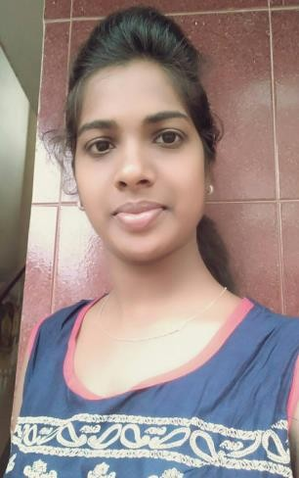RESUME

GENDER: Female NATIONALITY: Indian
FATHER’S NAME:
Satyanarayana

DATE OF BIRTH
20/4/1993

MOBILE NO 7019542519
8050350855
E-MAIL
sarupilot@gmail.com
SARITHA S
- CAREER OBJECTIVE :
Skilled Aircraft maintenance engineer ( AVIONICS) committed to provide excellent service to safeguard air travelers . Successful in reviewing project and tracking margins for process improvement .
- EDUCATION :
  - Hindustan aviation academy Bangalore
Aircraft Maintenance Engineering – Aggregate 86%
  - DGCA LICENCE PAPER – PAPER 1 (PASSED)-86%
  - Jyothi Nivas pre university college PUC – Aggregate 70%
  - Ever shine high school SSLC – Aggregate 86%
  - Cambridge English :Business Certificate (BEC)

- PROFESSIONAL EXPERIENCE :
  - 6months Trainee Technician at Air works hosur(Base)
- AIRBUS A-320 , BOEING B-737/700/800 , ATR 72
* English Trainer at Focus English Institute Bangalore.

ADDRESS
- saritha nivas oil
mill road Kammanahalli Bangalore 560084

  - LANGUAGE English Hindi, Kannada , Telugu,
Tamil RELIGION: Hindu
MARITAL STATUS:
SINGLE

PASSPORT NO P5720750

- SKILLS :
  - Team Leadership * Entrepreneur *Trainer
  - Aircraft system expertise *Team coordination * good communication skills

- EXTRACURRICULAR EXPERIENCE:
  - Exhibitor at Career Ustav Bangalore
  - Event Management at college program
- DECALARATION :
I Here by declare that about given information is true as per my knowledge .

Bangalore SARITHA S
DATE :

